Open Palaeontology style guide

Please use this guide to format your text submission for Open Palaeontology. Ideally, this should be done prior to submission (whether for preprinting or for peer review), though these are guidelines, and we do not provide detailed copy-editing services except in exceptional circumstances where assistance is needed with clarity.

Authors are not required to submit a cover letter with their submission but are free to do so if they desire.

1 Templates and typesetting
For initial submissions: a .docx template for general manuscript structure is provided here and should be used at minimum.
If desired for preprints or post-review: an online overleaf LaTeX template for typeset articles is also provided here. Authors may use this template to format their preprint submissions, or their post-peer review articles, though are not obligated to do so. Author-led typesetting using this template means you are free to choose placement of figures and tables in the final article, however, if you are not comfortable with using this template an Open Palaeontology Handling Editor will typeset your submission prior to publication on the website.

2 General style
- Manuscripts should be written in British English (-ise, palaeo-) or American English (-ize, paleo-), as long as the language used is consistent.
- A maximum of three heading levels should be used.
- Clear and accessible language should be used to ensure articles are understandable to those whose first language is not English.
- Abbreviations, acronyms, and technical terms should be defined on first use. If your manuscript contains many abbreviations and acronyms, we suggest including a separate ‘Abbreviations’ section to summarise these.
- Footnotes are not allowed, except within tables where necessary.
- Standard (SI) units should be used: https://physics.nist.gov/cuu/pdf/sp811.pdf
- Give names of manufacturers of uncommon laboratory instruments or software.
- Equations used should be in an editable format, rather than uneditable images.
- Geological timescale names should follow the International Committee on Stratigraphy standard, where possible: https://stratigraphy.org/chart. Capitalisation should only be used for time periods where they are proper names in the ICS, for example ‘early Ordovician’ (not ‘Early) and ‘Lower Ordovician’ (not ‘lower’).
- The title and all headings should be in sentence case and concise. Ideally, titles present the main finding of the manuscript.
- For more manuscript structure details, see the submission template file and instructions for authors.

3 Figures
- Figure dimensions: full-page width is 180 mm, single-column width is 80 mm, maximum height is 260 mm (see example below). You may include 2/3 width figures; however, text will not be set alongside them.
- For initial submissions (preprints, manuscripts under review) figures and tables can be either inserted at appropriate points throughout the manuscript with their captions, or in a list at the end of the manuscript file. For accepted post-peer review manuscripts figures and tables should be submitted as separate files, with captions listed at the end of the manuscript (unless author-typeset, in which you are free to choose the placement of figures and tables yourself).
- File formats: .tiff for vector graphics, .pdf or .eps for raster graphics.
- Resolution should be a minimum of 300 dpi, ideally 600 dpi.
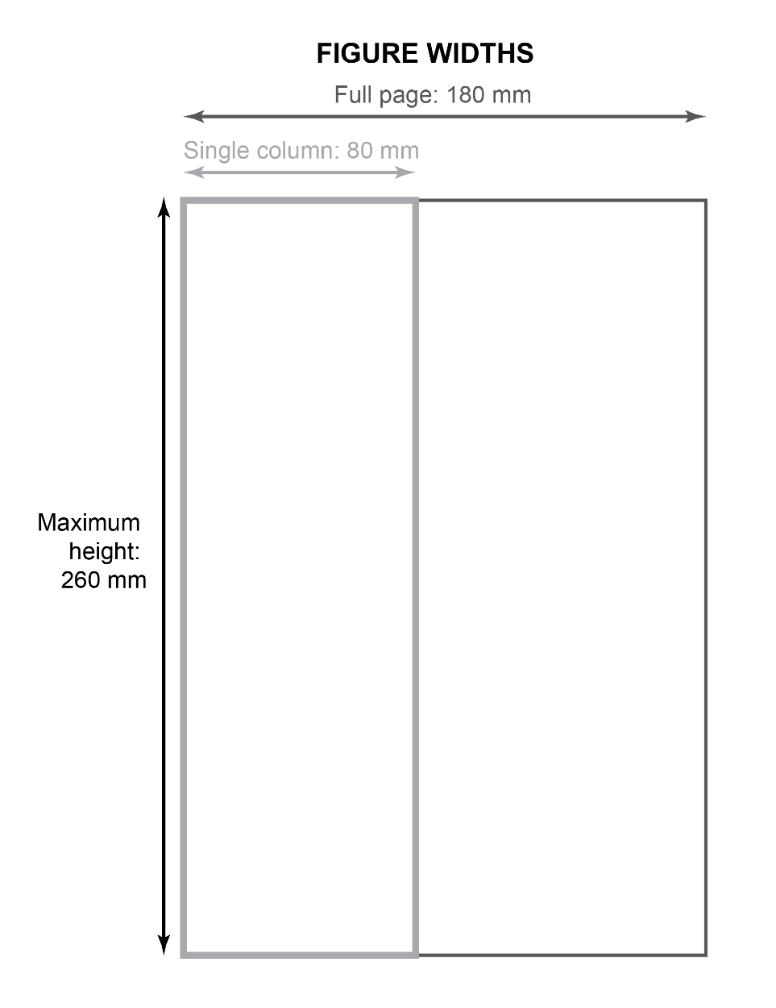
Figure 1: An example figure and caption, displaying the suitable figure sizes.

- All text within figures (panels, labels, etc.) should be sans serif and a minimum of 8 pt at their final dimensions. Line widths should be a minimum of 0.5 pt and symbols minimum of 6 pt at final size. Fonts in figures should be sans serif.
- Figures with multiple panels should label these using bold, ordered, capital letters in 10 pt, that is, A, B, C, etc. The panels must be defined in the figure caption.
- All illustrations should be referred to in the text as ‘Figure #’ if in plain text and ‘(Fig. #)’ if within parentheses. Figures should be referred to in chronological order in the manuscript. Multiple figures should be referred to as ‘Figures 1−3’ (i.e., using an en-dash), ‘(Figs 1−3)’, ‘Figures 1 and 2’, or ‘(Figs 1 and 2)’.
- Scale bars should be included in the figure without text and defined in the figure caption.
- Figure captions should clearly explain all parts of the figure if there are multiple panels, contain definitions for all abbreviations, and descriptions of all statistical conventions present in the figure (e.g., explanation of error bars).
- Plots should show all underlying data points where appropriate (when using, e.g., morphospaces, box plots, etc.). Error bars should be included in all appropriate plots, with the bars defined in the caption.
- Authors must ensure their figures are legible to everyone. This requires using accessible colours, ensuring meaning is conveyed not just by colour (i.e., plotting different samples using different symbols/lines as well as colours and including these in the legend, or by labelling lines directly), and using sufficiently thick line weights. Many free tools exist for the accessible colouring of figures, such as ColorOracle or SimDaltonism (plus R packages like colorblindcheck and colorblindr) to allow visualisation under different colour-vision deficiencies, and various R packages (e.g., colorbrewer, viridis, cols4all) that provide accessible palettes.
- For accessibility, please also provide a short alt text sentence to accompany each image. This should follow the figure caption. If not provided, the first sentence of the figure caption will be used.
- Avoid drawing contested borders or names on maps. If these are required for the map, use politically neutral labelling and legends, and use the United Nations naming conventions for maps: https://www.un.org/geospatial/mapsgeo.
- Images obtained, reproduced, and/or adapted from elsewhere must be accompanied by permission from the copyright holder (if permission for use is needed), and the credit line must be provided in the manuscript. If previously published data are used the source of the data must be credited in the manuscript.
- We do not allow the use of generative AI figures, except where they are the subject of the research presented. Please see our Code of Conduct for more information.

4 Tables
- Do not include any shading or colouring in tables unless this is necessary for meaning.
- Figures in the table are given to the same number of significant figures (three in the example below).
- Tables should be editable (not images) and included within the manuscript file, or post-acceptance can be included as a separate editable .doc file. Tables larger than one A4 page should be submitted as a separate supplementary information file in a .xls or .csv file.
- All tables should be referred to in the text as ‘Table #’ if in plain text and ‘(Table #)’ within parentheses. Tables should be referred to in chronological order in the manuscript. Multiple tables should be referred to as ‘Tables 1−3’ or ‘Tables 1 and 2’.
- The table number and caption for the table should be placed immediately above the table. An example of a table formatted in a .doc file is given below.

Table 1: An example of a table with the proper layout.
 | Header 1 | Header 2 | Header 3
Sample A | an example | 0.0123 | text is left-aligned
Sample B | of a table | 1.04 | numbers are centred

5 Lists
- For short lists, use an inline list organised like so: (1) organised; (2) like; (3) this.
- For long lists, use either regular bullet points or a numbered list, as below. Numbered lists imply a sequence or a finite amount of points.
- Each list item should have an initial capitalisation and a final full stop if the items represent full/multiple sentences. If not representing full sentences, there should be no initial capitalisation and only a full stop at the end of the last list item – see the examples below.

- item 1
- item 2
- item 3.
- This is the first item in the list.
- This is the second item in the list.
- This is the third item in the list.

6 Statistical reporting
- Results of all statistical tests, including the test value and p-value, should be either reported in the manuscript (where directly referred to in evidencing a point, or in a table) or in the supplementary information (if there are many tests to report).
- Authors should pay attention to statistical corrections for multiple tests (e.g., Bonferroni correction), and the meaning behind test results (i.e., their magnitude rather than just the p-value).
- Statistical analyses should be fully explained in the article methods section. This includes what analyses were performed, why, and what they show. How these analyses were performed should also be explained, such as the code packages used with their versions given and fully cited.
- For equations or manuscript text variables should be written in italic serif font, for example ‘p value’ or ‘V’.

7 Specimen and data access
- All specimens must be deposited in a recognised museum or accessible collection to be included in the study. The accession numbers for all specimens must be provided in the text or supplementary information at initial submission. Specimens in private collections or otherwise not available for study by all cannot be included.
- Open Palaeontology takes a strong stance on the ethics of specimen access. For example, if export permits are required for certain material then these must be provided at manuscript submission – see the Code of Conduct for full details on specimen ethics.
- Detailed information on the provenance of specimens should be included within the manuscript and/or the supplementary information, whether or not the country of origin has laws covering extraction of palaeontological material.

8 New taxa
- Open Palaeontology accepts the publishing of new taxa. All new zoological (including extinct) taxa must be registered on ZooBank at the point of acceptance. Following this, each new taxon LSID should be inserted within the manuscript after the heading for that taxon in the section on systematic palaeontology. Manuscripts will not be published as typeset versions without these LSIDs being added. If you are unsure whether your new taxa are appropriate for ZooBank registration it is better to create a new entry than not. Acritarchs and fossil plants should be registered on the PFNR. Diatoms should be registered on DiatomBase.
- Please do not include new taxon names in preprints as this can lead to confusion if the taxonomy is altered during review. Instead substitute the new taxon name with a consistent, readily understandable replacement, for example, Anomalocaris openpalaeoi n. sp. would be preprinted as Anomalocaris <newspecies> n. sp.
- After publication, you must update the ZooBank entry of the new taxon with the publication DOI, and release the entry.
- All new taxon descriptions must follow the relevant international code or guidance: https://www.iczn.org/the-code/the-code-online/ (ICZN; zoology), https://www.iaptglobal.org/icn (IAPT; algae, fungi and plants) or https://www.plantfossilnames.org (PFNR; fossil plants), https://www.diatombase.org (DiatomBase; diatoms).

9 Systematic palaeontology section
- Headings in the systematic palaeontology section should be centre aligned.
- Each taxon level should be accompanied by the authority and year of publication.
- Commas should be placed between authors and dates for taxon authorities (e.g., Raymond, 1935).
- Use bold font for taxon names (e.g., Anomalocarididae, Anomalocaris), except for the final species name.
- Use ‘gen. nov.’, ‘sp. nov.’, or ‘gen. et sp. nov’ to indicate new genera, new species, or new genus and species respectively.
- Use ‘comb. nov.’ for a new combination.
- The synonymy list should list all previous taxon names as they were published, in order of date of publication.
- References for taxon authorities and synonymy lists should be included in the reference list at the end of the manuscript.
- New taxon names should be compliant with our Code of Conduct, and Open Palaeontology reserves the right not to publish taxonomic acts, for example, if they could be considered offensive. Many resources exist to aid inclusive naming, for example the following articles:
https://royalsocietypublishing.org/doi/10.1098/rspb.2021.2708
https://www.nature.com/articles/s41599-021-00975-8
https://www.researchgate.net/publication/371695912_Inclusive_and_productive_ways_forward_needed_for_species-naming_conventions
- At the first mention of a species in the manuscript the full genus assignment should be given, with the species name in italics (e.g., Estaingia bilobata). Subsequent mentions can replace this genus name with the first letter capitalised followed by a full stop, or multiple letters if the first letter is shared with another genus mentioned in the paper (e.g., E. bilobata or Es. bilobata).
- At first mention of a species, the taxonomic authority should also be included, formatted like a standard text reference. For example, Estaingia bilobata (Pocock, 1964).
- Taxonomic levels higher than genus should not be in italics, but should be capitalised. If using the common name for the group, rather than the formal taxonomic name, it should not be capitalised. For example, Agnostida versus agnostid.
- See the two examples below for help in organising your systematic palaeontology section:

9.1 Example systematic palaeontology section, including use of open nomenclature

Family Anomalocarididae Raymond, 1935
Genus Anomalocaris Whiteaves, 1892

Type species. Anomalocaris canadensis Whiteaves, 1892; from the Burgess Shale Formation (Cambrian: Wuliuan), British Columbia, Canada.

Included species. [species in addition to the type species listed here].

Derivation of name. [only if new names are defined].

Diagnosis. [if new genus or if amended from previous].

Remarks. [optional].

Anomalocaris pennsylvanica Resser, 1929
Figure 3

1929 Anomalocaris pennsylvanica; Resser, pl. 5, fig. 5, pl. 79, fig. 5
1938 Anomalocaris pennsylvanica; Resser and Howell, pl. 10, fig. 4
1979 Anomalocaris pennsylvanica; Briggs, pl. 79, fig. 5, text-fig. 18, pp. 641

Holotype. USNM 80487 (part and counterpart), an isolated frontal appendage.

Type locality. Locality 12x (Resser 1929). One- and three-quarter miles north of Rohrerstown, Pennsylvania, USA.

Paratype. YPM 10425 (part only), an isolated frontal appendage.

Additional material. USNM 255611 (part only), a partial frontal appendage.

Diagnosis. [add text for diagnosis here].

Description. [add text for description here].

Remarks. [add text for remarks here].

Occurrence. Kinzers Formation (Cambrian: Stage 4). Localities 12x (one- and three-quarter miles north of Rohrerstown) and 22L (half a mile south of East Petersberg), both Pennsylvania, USA (Resser, 1929).

Anomalocaris cf. canadensis
Figures 4 and 5

Material. NHMUK PAL 0001, USNM 002, YPM 003. Complete frontal appendages.

Description. [add text for description here].
Remarks. [add text for remarks here].

Occurrence. Lower Cycle 6 of the Spence Shale Member (Cambrian: Wuliuan, Glossopleura walcotti Biozone) of the Langston Formation, Miners Hollow locality, Wellsville Mountains, Box Elder County, Utah. GPS coordinates: XXX, YYY.

Anomalocaris sp.
Figures 6 and 7

Material. JY-1999AB (part and counterpart), incomplete frontal appendages preserving only distal region.

Description. [add text for description here].
Remarks. [add text for remarks here].

Occurrence. Middle member of the Shuijingtuo Formation, Tsunyidiscus–Sinodiscus Assemblage Zone, Stage 3, Series 2, Cambrian, Jinyangkou Section of Changyang County, Hubei Province, China.

9.2 Example systematic palaeontology section, including extended synonymy list

Superclass Gnathostomata Gegenbaur, 1874
Class Chondrichthyes Huxley, 1880
Genus Vernicomacanthus Miles, 1973

Type species. Vernicomacanthus uncinatus Powrie, 1864 (= Climatius uncinatus Powrie, 1864).

Type specimen. NMS G.1891.92.208 (Fig. 3) is the lectotype.

Remarks. [optional].
Vernicomacanthus uncinatus Powrie, 1864
Figures 1–12

1858 ‘Balruddery spines’; Miller, p. 160, 1 ﬁg.
1864 Climatius uncinatus; Powrie (ex Egerton MS), pp 422–423.
1867 Climatius uncinatus; Anonymous, p. 7, 2 ﬁgs.
1870 Climatius uncinatus; Powrie, p. 296, pl. 14 ﬁg. 11.
1874 C. uncinatus Eg.; Barkas, p. 549.
1881 Climatius Uncinatus; Powrie, p. 168.
1890 Climatius uncinatus; Powrie (ex Egerton, MS); Woodward and Sherborn, p. 37.
1891 Climatius uncinatus; Powrie; Woodward, p. 30.
1892 Climatius uncinatus; Powrie; Traquair, p. 3.
1907 Climatius uncinatus; Dean, p. 216, 222, ﬁg. 24.
1912 Climatius uncinatus; Powrie; Hickling, table.
1973 Vernicomacanthus uncinatus; Miles, p. 140, pl. 7 ﬁg. 33.
1976 Vernicomacanthus uncinatus; Powrie (ex Egerton MS); Paton, p. 5.
1979 Vernicomacanthus uncinatus; Powrie; Denison, p. 30, ﬁg. 14F.
1999a Vernicomacanthus uncinatus; Powrie; Dineley, p. 150, 154.
2007 Vernicomacanthus uncinatus; Powrie; Burrow, p. 827.
2008 Vernicomacanthus uncinatus; Powrie; Burrow et al., p. 907.
2010 Vernicomacanthus uncinatus; Powrie (ex Egerton MS); Newman and Davidson, pp 22–24, ﬁgs 28–30.
2012 ‘Climatius’ uncinatus; Powrie; Newman et al., p. 758.
2015 C. uncinatus; Burrow et al., p.3.
2016 Vernicomacanthus uncinatus; Jerve et al., p. 21.
2017 Vernicomacanthus uncinatus; Maisey et al., pp 11–13, ﬁg. 7B.

Material. NHMUK PV P 1342a, NHMUK PV P 6960, NHMUK PV P 1342, NMS G.1891.92.208 (lectotype), NHMUK PV P 6968, NMS G.2001.7.4, counterparts NMS G.1891.92.209 and
DUNMG Kinnaird 82, counterparts NMS G.1891.92.210 and NH Mitchell 57, NMS G.1885.54.69, NMS G.2018.18.1.

Occurrence. Fossils of V. uncinatus are known from Tillywhandland (‘Turin Hill’) and Canterland Den (NHMUK PV P 6967, a pectoral ﬁn spine) near Forfar, and Balruddery Den, near Dundee, all in Angus, UK. The horizon from which the fossils come is the Arbuthnott–Garvock Group, Dundee Flagstone Formation, Lower Old Red Sandstone.

Emended diagnosis. As for genus.
10 Supplementary information
- All data and code generated, in both raw and clean versions, should be submitted as supplementary information along with the manuscript at initial submission. These should also be deposited with an open access hosting platform for perpetuity, such as the OSF or GitHub.
- Data can also be published on a specialist open access platform (particularly if the file sizes are too large to accompany the article), for example, MorphoSource for 3D models and tomographic data, MorphoBank for phylogenetic data, GenBank for sequence data, etc.
- A data and code availability statement must be included at the end of your manuscript detailing where (between supplementary information and external repositories) all data and code are freely available.
- If data has been used from other published studies or databases these must be cited, either within the manuscript if they are few, or included within the supplementary information. We strongly encourage citing these data sources in the manuscript directly; to facilitate this we place no limits on manuscript reference lists.
- See the Code of Conduct for more information on supplementary information.

11 References
- References should be formatted following the below examples, and all DOIs provided where possible.
  - Journal article: Palaeontologist, A.B., Archaeologist, C.D. and Geologist, E.F. 2000. This is an example reference. The Journal of Examples 1:2, 1–20. DOI.
  - Book chapter: Palaeontologist, A.B. 2000. An example book chapter title. In: Archaeologist, C.D. and Geologist, E.F. (Eds.) The title of the entire book. The Book Publisher. 1–20. DOI.
  - Entire book: Palaeontologist, A.B. 2000. An example book title. The Book Publisher. 100 pp. DOI.
  - Webpage: Palaeontologist, A.B. 2000. The title of my webpage. Accessed: 22nd August 2024. URL.
  - Newspaper article: Palaeontologist, A.B. 2000. The title of my newspaper article. The Example Newspaper. Accessed: 22nd August 2024. URL.
- Page numbers in the reference list should be separated by an en-dash not a hyphen (Alt+0150 Windows, option+hyphen Mac).
- References should be cited in the text in chronological order, using ‘et al.’ if there are more than two authors. Different author references should be separated by a semicolon, and the years separated by a comma if the author is identical. For example, (Palaeontologist, 2000, 2001, 2011; Geologist et al., 2010).
- References should be presented in the ‘References’ section at the end of the manuscript in alphabetical order, then chronologically for references with the same authors. If more than one reference has the same authors and year (including as ‘Name et al.’), they should be labelled with a letter following the year (e.g., ‘Name et al., 2000a, 2000b) in both the text and reference list.

12 Inclusive language
- Avoid the use of she/her/he/him where possible; in almost all cases this can be replaced with a name, ‘the author’, or ‘they’.
- Every effort should be made to use the local names for key landmarks, geographical regions, etc. If there is a concern with name recognition, then the local name should be used in addition to the ‘internationalised’ name. For example, in referring to the mountain Yr Wyddfa, also known as Snowdon. We also welcome names given in non-roman typescripts alongside the roman-typescript name.
- Some good general resources for using inclusive language are: https://www.diversitystyleguide.com
https://www.apa.org/about/apa/equity-diversity-inclusion/language-guidelines
https://www.acs.org/about/diversity/inclusivity-style-guide.html#general-guidelines

13 Specific spelling, punctuation and grammar notes

- ‘for example’ in text, ‘e.g.,’ only within parentheses
- ‘that is’ in text, ‘i.e.,’ only within parentheses
- ‘Earth’ not ‘earth’, same for other planets; ‘earth’ when referring to the substrate
- ampersands (&) are only used if they are part of official names
- name initials have full stops between (e.g., A.B. Palaeontologist)
- Latin abbreviations and words are not italicised (e.g., etc., in situ) unless they are uncommonly used
- only use capital letters if they are absolutely necessary (e.g., Department of Earth Sciences, but the department; University of Place, but the university)
- capitalise all words in titles (e.g., books) except articles, prepositions and conjunctions (e.g., World of Warcraft)
- spell out whole-number words for one to ten; use figures for 11 and up
- if there are many numbers in a sentence or paragraph, use only figures
- write out ‘first’ to ‘tenth’; use figures plus st/nd/rd/th above tenth, not in superscript
- do not write ‘percent’ after a figure, use the symbol (e.g., 10%)

- do not write out measurements or currency units, use the symbols (e.g., 10 mm or €10)
- insert a space between the figure and the unit symbol, except for percentages
- dates are written day month year (e.g., 1 February 2025)
- number ranges are separated by an en-dash (e.g., 1–5)
- “” are used to enclose direct quotes
- ‘’ are used for everything else (to highlight particular phrases, to use uncommon phrasing, etc.)
- ellipses should not have a space before them, and can be used to show text is missing (e.g., from a quotation)
- in general, text should not be in bold or italics (except for headings and species names)
- avoid use of underlining
- ‘less’ is used for uncountable nouns (e.g., less information); ‘fewer’ is used for countable nouns (e.g., fewer people)
- as a verb, ‘effect’ means to being about a result; ‘affect’ means to directly change something
- as a noun, ‘effect’ means the impact something causes; ‘affect’ means the outward appearance of a psychological state
- use the required non-English-language accents on letters (e.g., ‘lagerstätte’)
- use appropriate non-English-language plural forms (e.g., ‘nucleus/nuclei’, ‘genus’/’genera’, ‘librigena’/’librigenae’, ‘bacterium’/’bacteria’, ‘formula’/’formulae’)
- ‘significant’ should only be used when discussing statistical significance
- ‘comprise’ (not ‘comprise of’), but ‘consist of’
- ‘stationary’ (not moving)
- ‘program’ (computer program), ‘programme’ (a schedule, events)

